 | 12.1.17 Editors - Geometry Nodes Editor - Header - Add Menu - Utilities
Table of content
Detailed table of content 1
Add menu - Utilities 5
Align Euler to Vector 5
Boolean Math 6
Clamp 6
Float Compare 7
Float Curve 8
Float to Integer 9
Map Range 9
Math 10
Random Value 15
Rotate Euler 15
Switch 16

Detailed table of content
Detailed table of content
Detailed table of content 1
Add menu - Utilities 5
Align Euler to Vector 5
Inputs 5
Rotation 5
Factor 5
Vector 5
Properties 5
Align Axis 5
Pivot 5
Output 5
Rotation 5
Boolean Math 6
Inputs 6
Boolean 6
Properties 6
Operation 6
And 6
Or 6
Not 6
Output 6
Clamp 6
Inputs 6
Value 6
Min 6
Max 6
Properties 7
Clamp Type 7
Min Max 7
Range 7
Outputs 7
Result 7
Float Compare 7
Inputs 7
A, B 7
Properties 7
Operation 7
A is less than B 7
A is lesser than or equal B 7
A is greater than B 7
A is greater than or equal B 7
A is equal B 7
A is not equal B 7
Output 8
Result 8
Float Curve 8
Inputs 8
Factor 8
Attribute 8
Properties 8
Curve Widget 8
Navigation elements 8
Zoom in and out 8
Tools 8
Reset View 8
Vector Handle 8
Auto Handle 8
Auto Clamped Handle 9
Extend Horizontal 9
Extend Extrapolation 9
Reset Curve 9
Float to Integer 9
Inputs 9
Float 9
Properties 9
Rounding Mode 9
Outputs 9
Integer 9
Map Range 9
Inputs 9
Value 9
From Min 10
From Max 10
To Min 10
To Max 10
Properties 10
Interpolation Type 10
Clamp 10
Outputs 10
Value 10
Math 10
Inputs 10
Value 10
Addend 10
Base 10
Exponent 11
Epsilon 11
Distance 11
Min 11
Max 11
Increment 11
Scale 11
Degrees 11
Radians 11
Properties 11
Operation 11
Functions 11
Add 11
Subtract 11
Multiply 11
Divide 12
Multiply Add 12
Power 12
Logarithm 12
Square Root 12
Inverse Square Root 12
Absolute 12
Exponent 12
Comparison 12
Minimum 12
Maximum 12
Less Than 12
Greater Than 12
Sign 12
Compare 12
Smooth Minimum 12
Smooth Maximum 12
Rounding 13
Round 13
Floor 13
Ceil 13
Truncate 13
Fraction 13
Modulo 13
Wrap 13
Snap 13
Ping-pong 13
Trigonometric 13
Sine 13
Cosine 13
Tangent 13
Arcsine 13
Arccosine 13
Arctangent 13
Arctan2 14
Hyperbolic Sine 14
Hyperbolic Cosine 14
Hyperbolic Tangent 14
Conversion 14
To Radians 14
To Degrees 14
Clamp 14
Outputs 14
Value 14
Use Clipping 14
Delete Points 14
Curve window 14
X / Y values 14
Random Value 15
Input 15
Min 15
Max 15
ID 15
Seed 15
Properties 15
Data Type 15
Output 15
Value 15
Rotate Euler 15
Inputs 15
Rotation 15
Rotate By 15
Properties 16
Rotate Type 16
Axis Angle 16
Euler 16
Rotate Space 16
Object 16
Point 16
Outputs 16
Rotation 16
Switch 16
Inputs 16
Switch 16
A 16
B 16
Properties 17
Input Type 17
Outputs 17
Output 17

Add menu - Utilities
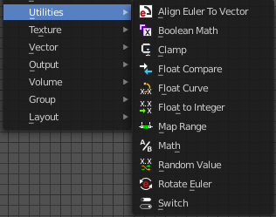
Utility nodes are mainly for mathematical operations.

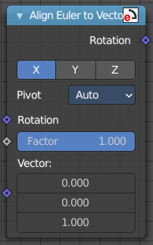
Align Euler to Vector
Aligns a euler value to a vector.

Inputs

Rotation
The input euler rotation vector.

Factor
The factor to align the euler value to the vector.

Vector
The vector to align to.

Properties

Align Axis
To which axis to align the vector.

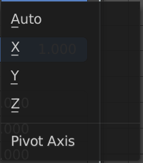
Pivot
The pivot axis.

Output

Rotation
The output rotation euler angle.

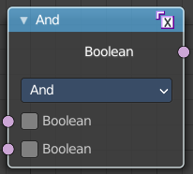
Boolean Math
The Boolean Math node performs a basic logical operation between its inputs.

Inputs

Boolean
Two standard Boolean inputs.

Properties

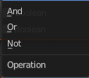
Operation

And
True if both inputs are true.

Or
True if either or both inputs are true.

Not
True if both inputs are false.

Output
Boolean
Standard Boolean output.

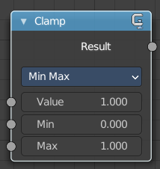
Clamp
Clamps a value between a minimum and a maximum.

Inputs

Value
The input value to be clamped.

Min
The minimum value.

Max
The maximum value.

Properties

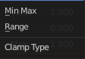
Clamp Type

Min Max
Clamp values using Min and Max values.

Range
Clamp values between Min and Max range.

Outputs

Result
The input value after clamping.

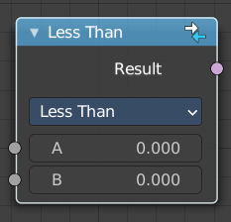
Float Compare
The Float Compare node takes two inputs and does a math comparison between them.

Inputs

A, B
Standard float value input.

Properties

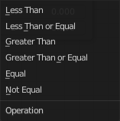
Operation

A is less than B
True if A is smaller than B.

A is lesser than or equal B
True if A is smaller or equal than B.

A is greater than B
True if A is bigger than B.

A is greater than or equal B
True if A is bigger or equal than B.

A is equal B
True if A and B are the same.

A is not equal B
True if A and B are different.

Output

Result
Standard Boolean output.

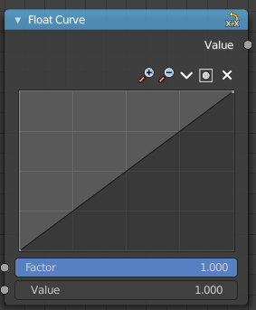
Float Curve
Generates a curve. This curve can then be used for profiles for example.

Inputs

Factor
The input factor.

Attribute
The input value.

Properties

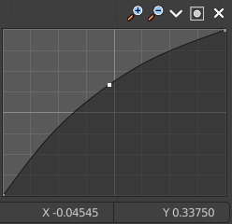
Curve Widget

Navigation elements
The navigation elements at the top are described from left to right.

Zoom in and out
The two buttons with the magnifying glass at it zooms in and out in the curve window.

Tools
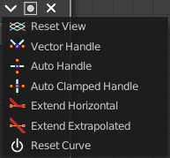
Tools is a menu where you can find some curve related tools.

Reset View
Resets the curve windows zoom.

Vector Handle
Set handle type to Vector.

Auto Handle
Set handle type to Auto.

Auto Clamped Handle
Set handle type to Auto Clamped.

Extend Horizontal
Extends the curve before the last point and after the last point horizontally.

Extend Extrapolation
Extends the curve before the last point and after the last point extrapolated.

Reset Curve
Resets the curve to the initial shape.

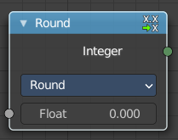
Float to Integer
Converts a floating point value into an integer value.

Inputs

Float
The input float value.

Properties

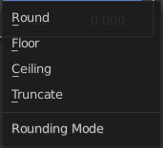
Rounding Mode
How the float value should be converted.

Outputs

Integer
The output integer value

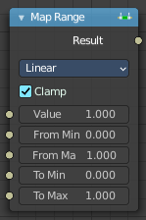
Map Range
This node converts (maps) an input value range into a destination range. By default, values outside the specified input range will be proportionally mapped as well. This node is similar to Map Value node but provides a more intuitive way to specify the desired output range.

Inputs

Value
Standard value input.

From Min
Start of the input value range.

From Max
End of the input value range.

To Min
Startof the destination range.

To Max
End of the destination range.

Properties

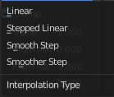
Interpolation Type
how to interpolate the values between min and max.

Clamp
Clamps values to Min/Max of the destination range.

Outputs

Value
Standard value output.

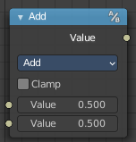
Math
The Math Node performs math operations.

Inputs
The inputs of the node are dynamic. Some inputs are only available with certain operations. For example, the Addend input is only available in the Multiply Add operator.

Value
Input Value. Trigonometric functions read this value as radians.

Addend
Input Addend.

Base
Input Base.

Exponent
Input Exponent.

Epsilon
Input Epsilon.

Distance
Input Distance.

Min
Input Minimum.

Max
Input Maximum.

Increment
Input Increment.

Scale
Input Scale.

Degrees
Input Degrees.

Radians
Input Radians.

Properties

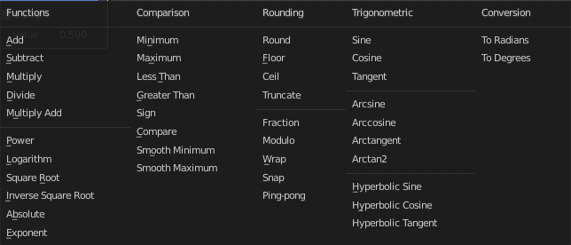
Operation
The mathematical operator to be applied to the input values:

Functions

Add
The sum of the two values.

Subtract
The difference between the two values.

Multiply
The product of the two values.

Divide
The division of the first value by the second value.

Multiply Add
The sum of the product of the two values with Addend.

Power
The Base raised to the power of Exponent.

Logarithm
The log of the value with a Base as its base.

Square Root
The square root of the value.

Inverse Square Root
One divided by the square root of the value.

Absolute
The input value is read with without regard to its sign. This turns negative values into positive values.

Exponent
Raises Euler’s number to the power of the value.

Comparison

Minimum
Outputs the smallest of the input values.

Maximum
Outputs the largest of two input values.

Less Than
Outputs 1.0 if the first value is smaller than the second value. Otherwise the output is 0.0.

Greater Than
Outputs 1.0 if the first value is larger than the second value. Otherwise the output is 0.0.

Sign
Extracts the sign of the input value. All positive numbers will output 1.0. All negative numbers will output -1.0. And 0.0 will output 0.0.

Compare
Outputs 1.0 if the difference between the two input values is less than or equal to Epsilon.

Smooth Minimum
Smooth Minimum.

Smooth Maximum
Smooth Maximum.

Rounding

Round
Round the input value to the nearest integer.

Floor
Rounds the input value down to the nearest integer.

Ceil
Rounds the input value up to the nearest integer.

Truncate
Outputs the integer part of the value.

Fraction
Fraction.

Modulo
Outputs the remainder once the first value is divided by the second value.

Wrap
Outputs a value between Min and Max based on the absolute difference between the input value and the nearest integer multiple of Max less than the value.

Snap
Round the input value to down to the nearest integer multiple of Increment.

Ping-pong
The output value is moved between 0.0 and the Scale based on the input value.

Trigonometric

Sine
The Sine of the input value.

Cosine
The Cosine of the input value.

Tangent
The Tangent of the input value.

Arcsine
The Arcsine of the input value.

Arccosine
The Arccosine of the input value.

Arctangent
The Arctangent of the input value.

Arctan2
Outputs the Inverse Tangent of the first value divided by the second value measured in radians.

Hyperbolic Sine
The Hyperbolic Sine of the input value.

Hyperbolic Cosine
The Hyperbolic Cosine of the input value.

Hyperbolic Tangent
The Hyperbolic Tangent of the input value.

Conversion

To Radians
Converts the input from degrees to radians.

To Degrees
Converts the input from radians to degrees.

Clamp
Limits the output to the range (0.0 to 1.0). See Clamp.

Outputs

Value
Numerical value output.


Use Clipping
Clipping options. Set up clipping for the stroke.

Delete Points
Deletes selected curve point.

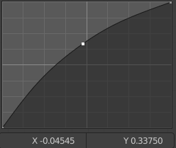
Curve window
Tweak and adjust the falloff curve by clicking at a curve point and dragging it around.
Double click adds a new point.
Holding down ctrl activates temporary snapping.
Holding down shift enables slower movement, which allows more accurate setting.

X / Y values
The x and y value of the currently selected point.

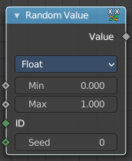
Random Value
Generates a random value.

Input

Min
The minimum value of the range.

Max
The maximum value of the range.

ID
Add an ID

Seed
The random seed

Properties

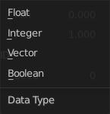
Data Type
What kind of random value to create. The items should be self explaining.

Output

Value
The output value.

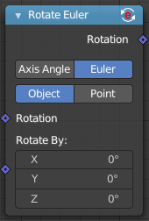
Rotate Euler
Modifies an input euler rotation.

Inputs

Rotation
Use the rotation of an existing geometry.

Rotate By
The input rotation.

Properties

Rotate Type

Axis Angle
Rotate around an axis by an angle.

Euler
Rotate around the x, y and z axis.

Rotate Space

Object
Rotate points in the local space of the object.

Point
Rotate every point in its local space.

Outputs

Rotation
The euler angle output.

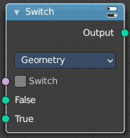
Switch
Switch between two inputs values based on a boolean.

Inputs

Switch
The boolean switch.

A
The input value A. Used when the switch is off.

B
The input value B. Used when the switch is on.

Properties

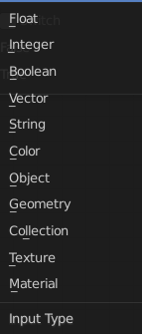
Input Type
What input type the values are, which defines what type to output then.

Outputs

Output
Numerical value output.

